“The importance of numeracy needs to be understood by everyone, and everyone needs to realise that they can get on with numbers with effort and support. But the greatest constraining factor - and the one that underlies almost every worrying aspect of the numeracy story - is negative attitudes.” National Numeracy Strategy 2025-2028

At Southfield Park we believe Maths is a subject that has the ability to transform our children’s lives. However, we also know that this transformation will only be possible if we teach the subject content alongside the skills and attitudes needed to get past barriers. By building determination and confidence in our learners, it will empower them to access future opportunities and thrive within a brighter future. As such we are fully committed to providing inclusive education through an equitable level of provision for all children, by implementing the following inclusive practices every learner can thrive:
- Adapting resources: Providing a wide range of tools and strategies such as manipulatives, visual aids, number frames, and assistive technology to support diverse learning styles and needs.

- Fostering supportive learning environments: Creating classrooms where every child feels valued and confident to participate. This involves setting clear, consistent routines, offering collaborative group activities, and using scaffolding techniques like sentence starters or guided examples. Our teachers use inclusive teaching strategies such as questioning that promotes deeper thinking and the use of open-ended tasks that allow for multiple entry points.
- Offering tailored interventions: Ensuring children who need extra help are supported through targeted small group or one-to-one sessions. These interventions may include precision teaching, focused fluency practice, or using specialist programs Times Table Rock Stars. Regular formative assessments ensure interventions are adapted to meet evolving needs and maximize progress.
By embedding these practices into our daily teaching, we aim to provide an enriching, equitable experience where all children can develop a love for mathematics and achieve their full potential.
The Five Big Ideas of Mastery
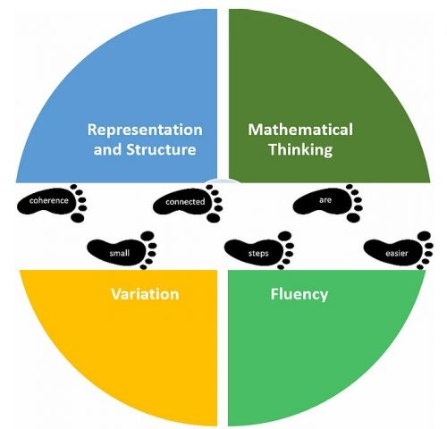 | - Representation and Structure  Objects and pictures are used to xxx the mathematical concepts being taught
- Mathematical Thinking
Ideas must be taught and understood deeply through thinking, reasoning and discussion
- Fluency
Quick and efficient recall of facts and procedures ensure the flexibility to move between different contexts and representations in maths efficiently.

- Variation
Varying the way, a concept is presented initially to stop mechanical repetition, encourage thinking a show the range of contexts the concept may be required to solve the question
- Coherence – all steps are small steps
Connecting new ides to concepts that have already been understood. Once mastered these new ideas need to be repeatedly used, again and again, in the next steps of learning.

Southfield Park’s Maths curriculum is taught through learning Mastery. This approach is designed to foster a sense of enjoyment and curiosity about the subject, develop a solid foundation of mathematical understanding and teach a love of problem solving. Through this the children will develop a deep understanding of the ‘The Five Big Ideas’ underpinning Mastery (refer to diagram above).
We ensure that links are made within the subject and across all curriculums, so that children’s learning is both broad and deep. Learning is contextualised and meaningful, with many practical resources and applications being exploited so that children develop strong models that they can refer to and apply to different situations both in school and in the workplace.
White Rose Scheme of Learning
Our Maths Mastery approach has been supported through the investment of the White Rose Maths scheme of learning, which is a research-driven government approved scheme that supports teachers with clear planning guidance following a small steps approach. The primary resources help teachers create maths lessons that meet all national curriculum guidelines in a fun, inclusive and age-appropriate way. All our material is designed to support primary children as they have fun with maths, exploring everything from times tables and number bonds to money and multiplication.

White Rose Maths Calculation Policy
The White Rose Maths calculation policy sets the expectation in progress through the teaching of addition, subtraction, multiplication, and division. The policy supports teachers to plan progressively, from Reception to Year 6, using the models and images provided. The document also provides guidance and expectations for the delivery of teaching of each operation for each year group.
The policy introduces key concepts using a Concrete, pictorial, and abstract (CPA) approach.

Concrete – Concrete is the “doing” stage.
During this stage, children use concrete objects to model problems. Unlike traditional maths teaching methods where teachers demonstrate how to solve a problem, the CPA approach brings concepts to life by allowing children to experience and handle physical (concrete) objects. For example, if a problem involves adding pieces of fruit, children can first handle actual fruit. From there, they can progress to handling abstract counters or cubes which represent the fruit.

Pictorial – Pictorial is the “seeing” stage.
Here, visual representations of concrete objects are used to model problems. This stage encourages children to make a mental connection between the physical object they just handled and the abstract pictures, diagrams or models that represent the objects from the problem.
Building or drawing a model makes it easier for children to grasp difficult abstract concepts (for example, fractions). Simply put, it helps students visualise abstract problems and make them more accessible.
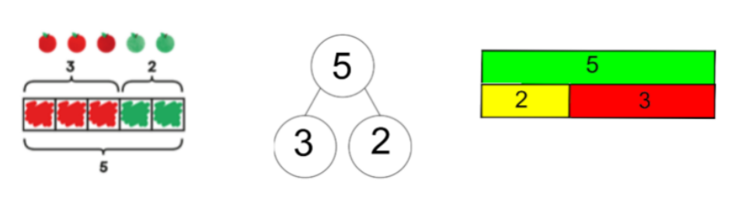
Abstract – Abstract is the “symbolic” stage.
Only once children are secure with the use of concrete and pictorial approaches to their calculation, reasoning and problem solving, they move on to use abstract symbols to model problems. They will not progress to this stage until they have demonstrated that they have a solid understanding of the concrete and pictorial stages of the problem, which they can still use to demonstrate their depth of fluency and understanding as they develop to consistently use standard written methods.
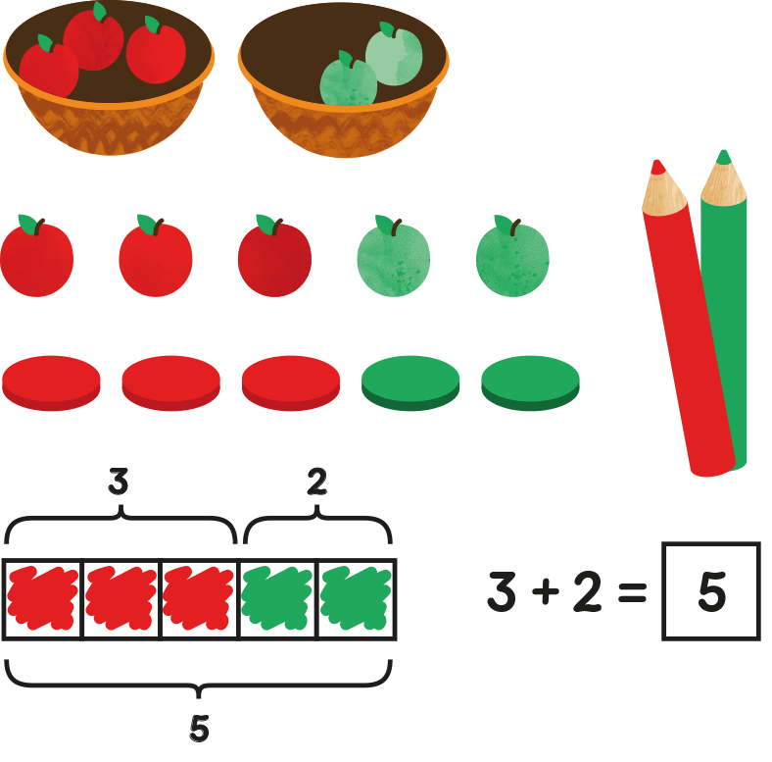
What does Mastery mean in practice?
In summary, a mastery approach enables our children to…
Be confident in their math skills and use mathematical language to explain their ideas.
Enjoy learning and have fun exploring mathematical concepts.
Experience real-world application so they understand the relevance to their lives, through the application of everyday situations.
Be fluent by focusing on depth before breadth and by having the time required to practice and reinforce skills and knowledge again and again.
Reason by following a line of enquiry mathematically and developing arguments, through their understanding of a wide range of mathematical representations.
Problem-solve by systematically working through a series of steps and using their knowledge to develop a resilient attitude and willingness to take risks.
Work collaboratively to support one another to achieve a common goal.
Does White Rose Maths only cover the teaching of calculation?
The White Rose scheme (and Mastering Number in Reception) cover all the essential topics in Reception, Key Stage 1 and Key Stage 2. We look to Instil positive attitudes at an early age as mathematical knowledge is an essential foundation in every child’s educational journey. The maths resources help children learn in fun, hands-on, practical ways and are aligned perfectly with the DfE EYFS statutory framework including the early learning goals. A significant amount of time is spent building the essential core skills that lay the solid foundation for more complicated learning as the children progress up through the Key Stages.
Each year group has a learning overview of the maths that your child will cover at each point in the year. The scheme of learning is split into three terms (autumn, spring and summer), and each term is further broken down into individual blocks of learning about a particular topic incorporating a series of small steps.
You can find out more about the White Rose Maths curriculum for each year group by following the Maths Tab ‘Progression of Learning’.
There are links to useful resources for parents in the tab Maths ‘Resources for Families’.

