Reception RE Topic Overview
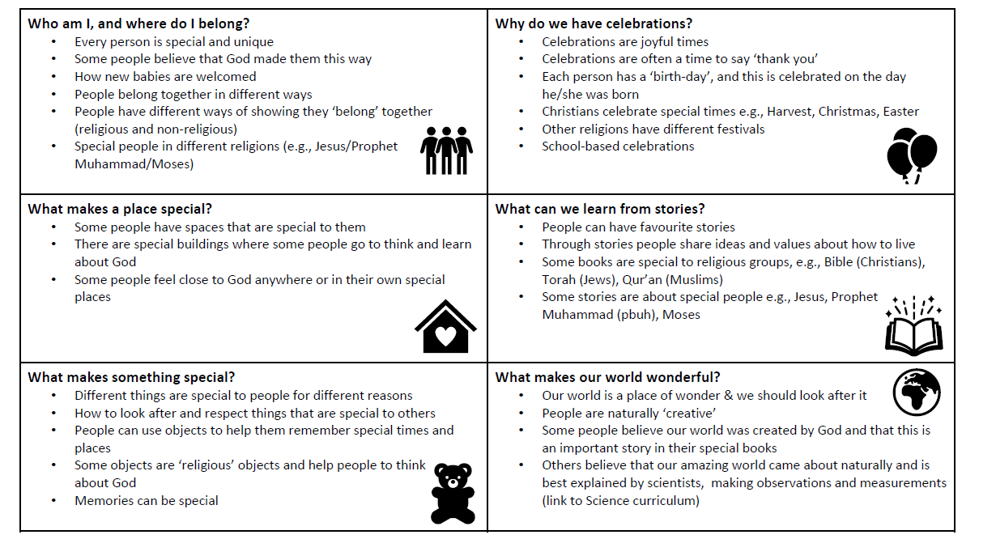

Year 1 RE Topic Overview
Autumn |  | Spring |  | Summer
1 | 2 | 1 | 2 | 1 | 2
Why do Christians call God ‘creator’? | What is the nativity and why is it important to Christians? | What do Christians learn from stories of Jesus? | What is the Torah, and why is it important to Jewish families? | Why do Jewish families celebrate the gift of Shabbat? | Thematic: Why should we look after the world?

Year 2 RE Topic Overview
Autumn |  | Spring |  | Summer
1 | 2 | 1 | 2 | 1 | 2
What is God like for Christians? | Why is giving important to Christians? | Why do Christians call Jesus ‘Saviour’? | What is important for Muslim families? | Who is Allah and how do Muslims worship him? | Thematic: Is giving better than receiving?

Year 3 RE Topic Overview
Autumn |  | Spring |  | Summer
1 | 2 | 1 | 2 | 1 | 2
What is the Bible’s ‘big story’ and why is it like treasure for Christians? | How did Jesus change lives and how is it ‘good news’? | How can artists help us to understand what Christians believe and do? | How does ‘ibadah’ (worship) show what is important to Muslims? | What are important times for Jewish people?  (Passover April) | Thematic: How do people try to make the world a fairer place?

Year 4 RE Topic Overview
Autumn |  | Spring |  | Summer
1 | 2 | 1 | 2 | 1 | 2
What do Sikhs value? | What did God promise to his people? | What did Jesus say about God’s Kingdom and why is it ‘good news’? | For Christians, is communion a celebration or an act of remembrance? | Humanism: How do non-religious people celebrate new life? | Thematic: Why do people make promises?

Year 5 RE Topic Overview
Autumn |  | Spring |  | Summer
1 | 2 | 1 | 2 | 1 | 2
What helps Muslims to live a good life? | What does it mean to be part of a synagogue community? | What do Christians believe about creation? | Why is the idea of ‘rescue’ so important to Christians?  (link to Easter) | How did the Church begin, and where is it now? | Thematic: What does it mean to live a good life?

Year 6 RE Topic Overview
Autumn |  | Spring |  | Summer
1 | 2 | 1 | 2 | 1 | 2
How is God three-and yet one? | What do Christians believe about the Messiah- and why is it good news? | For Christians, what difference does it make to belong to God’s kingdom? | What helps Hindus (santanis) to worship? | Why should Hindus live a good life? | What is the ‘Buddhist way of life?’  Thematic: Who am I and where do I belong?

